ASSIGNMENT-4

DISTANCE DETECTION USING ULTRASONIC SENSOR

|  |  |
| --- | --- |
| Date | 26 October 2022 |
| Team ID | PNT2022TMID18105 |
| Name | Tamilarasan D |
| Student Roll Number | 713319CS156 |
| Maximum Marks | 2 Marks |

# Question 1:

Write code and connections in wokwi for ultrasonic sensor. Whenever distance is less than 100 centimeters it should send "alert" to IBM cloud and display in device recent events.

CODE:

#include <WiFi.h>//library for wifi

#include <PubSubClient.h>//library for MQtt

void callback(char* subscribetopic, byte* payload, unsigned int payloadLength);

//-------credentials of IBM Accounts------

#define ORG "zq1b29"//IBM ORGANITION ID

#define DEVICE_TYPE "NodeMCU"//Device type mentioned in ibm watson IOT Platform

#define DEVICE_ID "23456"//Device ID mentioned in ibm watson IOT Platform

#define TOKEN "987654321"     //Token

String data3;

float dist;

//-------- Customise the above values --------

char server[] = ORG ".messaging.internetofthings.ibmcloud.com";// Server Name

char publishTopic[] = "iot-2/evt/Data/fmt/json";// topic name and type of event perform and format in which data to be send

char subscribetopic[] = "iot-2/cmd/command/fmt/String";// cmd  REPRESENT command type AND COMMAND IS TEST OF FORMAT STRING

char authMethod[] = "use-token-auth";// authentication method

char token[] = TOKEN;

char clientId[] = "d:" ORG ":" DEVICE_TYPE ":" DEVICE_ID;//client id

//-----------------------------------------

WiFiClient wifiClient; // creating the instance for wificlient

PubSubClient client(server, 1883, callback ,wifiClient); //calling the predefined client id by passing parameter like server id,portand wificredential

int LED=4;

int trig=5;

int echo=18;

void setup()

{

**Serial**.begin(115200);

  pinMode(trig,OUTPUT);

  pinMode(echo,INPUT);

  pinMode(LED,OUTPUT);

  delay(10);

  wificonnect();

  mqttconnect();

}

void loop()// Recursive Function

{

digitalWrite(trig,LOW);

 digitalWrite(trig,HIGH);

 delayMicroseconds(10);

 digitalWrite(trig,LOW);

 float dur=pulseIn(echo,HIGH);

 float dist=(dur*0.0343)/10;

**Serial**.print("Distance in cm");

**Serial**.println(dist);

  PublishData(dist);

  delay(1000);

  if (!client.loop()) {

    mqttconnect();

  }

}

/*.....................................retrieving to Cloud...............................*/

void PublishData(float dist) {

  mqttconnect();//function call for connecting to ibm

  /*

     creating the String in in form JSon to update the data to ibm cloud

  */

  String object;

  if(dist<100)

  {

    digitalWrite(LED,HIGH);

**Serial**.println("object is near");

    object="Near";

  }

  else{

     digitalWrite(LED,LOW);

**Serial**.println("no object found");

     object="No";

  }

  String payload = "{\"distance\":";

  payload += dist;

  payload += "," "\"object\":";

  payload += object;

  payload += "\"}";

**Serial**.print("Sending payload: ");

**Serial**.println(payload);

  if (client.publish(publishTopic, (char*) payload.c_str())) {

**Serial**.println("Publish ok");// if it sucessfully upload data on the cloud then it will print publish ok in Serial monitor or else it will print publish failed

  } else {

**Serial**.println("Publish failed");

  }

}

void mqttconnect() {

  if (!client.connected()) {

**Serial**.print("Reconnecting client to ");

**Serial**.println(server);

    while (!!!client.connect(clientId, authMethod, token)) {

**Serial**.print(".");

      delay(500);

    }

     initManagedDevice();

**Serial**.println();

  }

}

void wificonnect() //function defination for wificonnect

{

**Serial**.println();

**Serial**.print("Connecting to ");

  WiFi.begin("Wokwi-GUEST", "", 6);//passing the wifi credentials to establish the connection

  while (WiFi.status() != WL_CONNECTED) {

    delay(500);

**Serial**.print(".");

  }

**Serial**.println("");

**Serial**.println("WiFi connected");

**Serial**.println("IP address: ");

**Serial**.println(WiFi.localIP());

}

void initManagedDevice() {

  if (client.subscribe(subscribetopic)) {

**Serial**.println((subscribetopic));

**Serial**.println("subscribe to cmd OK");

  } else {

**Serial**.println("subscribe to cmd FAILED");

  }

}

void callback(char* subscribetopic, byte* payload, unsigned int payloadLength)

{

**Serial**.print("callback invoked for topic: ");

**Serial**.println(subscribetopic);

  for (int i = 0; i < payloadLength; i++) {

    //Serial.print((char)payload[i]);

    data3 += (char)payload[i];

  }

data3="";

}

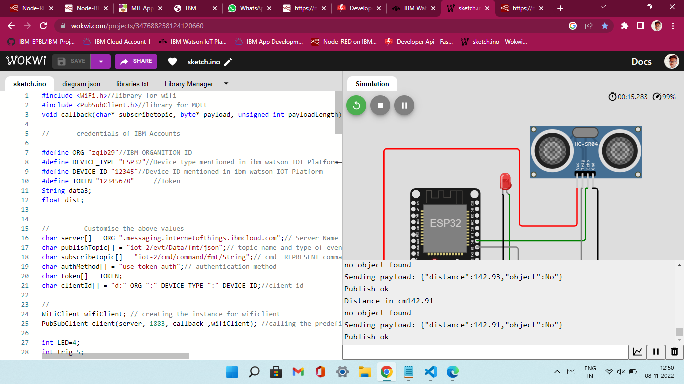

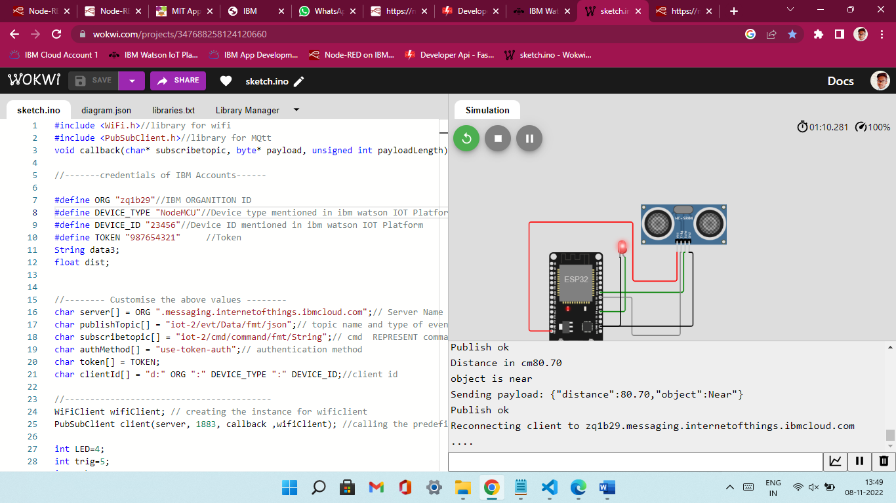

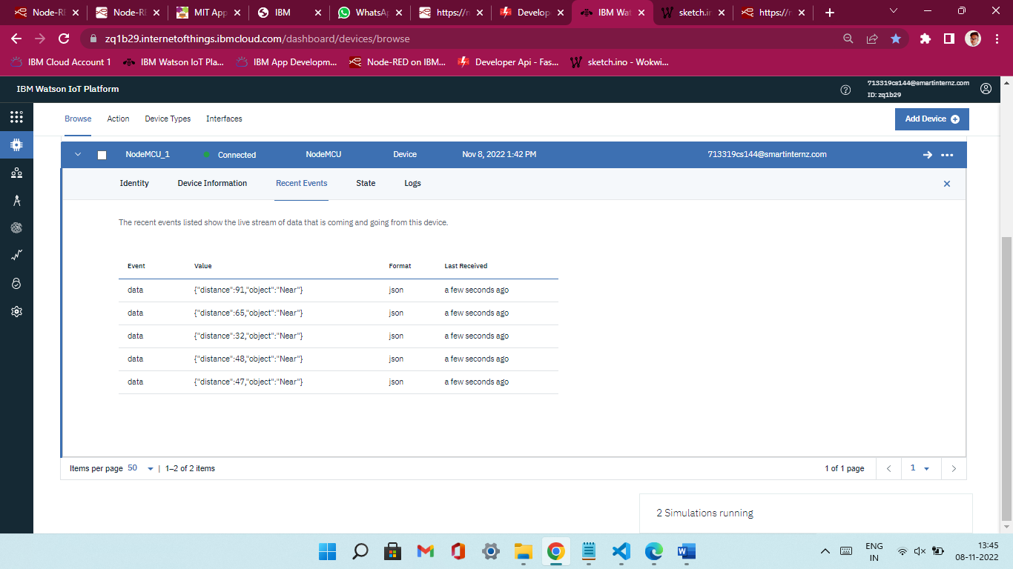

https://wokwi.com/projects/347688258124120660